Project Report

On

E-Mart

Submitted to

Information Technology Department

October 2015



Gujarat Technology University

Dr. S. & S. S. Ghandhy College of

Engineering & Technology

Surat

Dr. S. & S. S. Ghandhy College of

Engineering & Technology

Surat

Gujarat Technology University

5th Semester Project Report

On

E-Mart

Submitted to

Information Technology Department

October 2015

Guided by

Submitted by

Lect. S. M. Chauhan

(I.T. Dept.)

Chotaliya Vaibhav R.

Hirapara Jaydip V.

Tarpara Dhruv B.

136120316011

136120316014

136120316061

CERTIFICATE

Dr. S. & S. S. Ghandhy College of

Engineering & Technology

Surat

This is to certify that

1

2

3

Enrollment no.

136120316011

136120316014

136120316061

Name

Chotaliya Vaibhav R.

Hirpara Jaydip V.

Tarpara Dhruv B.

Have completed UDP Project work, having title E-Mart.

Guide

HOD

External Examiner

Principal

Acknowledgement

Before penning a single word for the project, we take this opportunity to thank all those who have helped us directly or indirectly in making our project live and turn it into a successful piece of work. Many people have contributed to this project in a variety of ways. Words are not enough to describe their support and faith in us. But still we want to thank all of them. Firstly, we would like to thank God and our parents who always bless us and motivate to achieve our desired goals in life.

We also express our thanks to Lect. S. M. Chauhan from bottom of our heart who guided us as much as possible and for giving us valuable information regarding to our project. The project would not have been successfully completed without continuous support, motivation extended by our colleagues and friends who were always with us.

This was the first professional step towards the high profile careers in IT field. So, we are thankful to Information Technology Department for facilities that are provided to us. It was a great experience of exposing as well as learning lot of new things in Information Technology.

I would like to thank Dr S. & S. S. Ghandhy College of Engineering & Technology for providing us the platform to represent the project.

Last, but not least, I am very thankful to all my friends for always keeping my spirits high.

Index

|  |  |  |
| --- | --- | --- |
| Sr.no | Topic | Page No. |
|  | Abstract | 7 |
| 1. | Project Profile | 9 |
|  | 1.1 Description | 10 |
|  | 1.2 Modules | 10 |
| 2. | Whole Industrial Process & Problem Study | 12 |
|  | 2.1 Problem Identification | 13 |
|  | 2.2 Detail Summary of Project | 13 |
|  | 2.3 Expected Outcomes | 14 |
| 3. | Requirement Analysis | 15 |
|  | 3.1 Problem Solving Technique | 16 |
|  | 3.2 Project Life Cycle Model | 17 |
|  | 3.3 Advantages of Model | 19 |
| 4. | System Design | 20 |
|  | 4.1 System Requirement Specification | 21 |
|  | 4.2 Organization Chart | 22 |
|  | 4.3 Entity Relationship Model | 23 |
|  | 4.4 Dataflow Diagram | 25 |
|  | 4.5 Data Dictionary | 30 |
| 5. | Form Layout | 33 |
| 6. | Tools Specification | 39 |
|  | 6.1 Software Specifications | 40 |
|  | 6.1.1 Front End | 40 |
|  | 6.1.2 Back End | 41 |
|  | 6.2 Other Tools | 42 |
|  |  |  |

|  |  |  |
| --- | --- | --- |
| 7. | Conclusion | 43 |
|  | 7.1 Advantages | 44 |
|  | 7.2 Limitations | 44 |
|  | 7.3 Future Scope | 44 |
| 8. | Bibliography | 45 |

**ABSTRACT**

Abstract

* E-mart is a website which provides a medium to connect seller and buyers in the e-commerce industry. It reduces time, effort, and expense of consumer and on the other hand provides a platform for the seller.
* The objective of this project is to develop general purpose e-commerce store where any product can be brought from the comfort of home to the internet.
* For the entrepreneur, electronic shopping generates new business opportunities means that there is a wider scope of consumer it makes comparative shopping possible.

**Chapter-1**

**Project Profile**

* 1. DESCRIPTION
* E-mart is a website which provides a medium to connect seller and buyers in the e-commerce industry. It reduces time, effort, and expense of consumer and on the other hand provides a platform for the seller.
* The objective of this project is to develop general purpose e-commerce store where any product can be brought from the comfort of home to the internet.
* For the entrepreneur, electronic shopping generates new business opportunities means that there is a wider scope of consumer it makes comparative shopping possible.

## Modules:

## There are mainly 3 Module in this system as given below:-

* Admin
* Buyer
* Seller

Here is The Module Play role:

* Admin
* Login
* Manage Buyers
* Manage Sellers
* Add/Remove Products

# Buyer

* Registration
* Login
* View Product
* Add to Cart
* Place Order

# Seller

* Registration
* Login
* Manage Profile
* Sell Products
* Change Order Status

.

Chapter-2

Whole Industrial Process

& Problem Study

2.1 Problem identification:-

* There is not many websites such that all variety of products are available.
* When the courier guy comes the buyer may or may be not at home.
* There is not such type of service like home delivery, COD for food products.
* Difficulty in buying & comparing products.
* Sellers have a limited scope of geographical area.
* In a single local store, they don’t have all the variety of products.

2.2 Detail summary of project:-

* The name of the website is E-mart which is made especially for purpose of buying grocery or any daily usable products in for prize.
* Many types of services is provided by E-mart like person will get description of all product but it is not necessary that visitors must have to buy things or products, they can also visit our website for getting information about products and compare them.
* Our website consists of main three modules.
  + Buyer
  + Seller
  + Admin
* First of all, buyer signup or goes into guest mode. In guest mode he/she can’t buy products, he/she only can view and get information about products.
* After signup, he/she Sign IN and then surf our website for desired products. He/she can also add products into wish list or cart and also place order and select time for delivery and simply logout.
* Seller is the person who will sell or deliver the products according to order and time.
* Seller checks the database and gets information of order and delivers products to buyer.
* Admin manages the whole website and have a full access over the website.
* Admin can add and remove products change the price and info.
* Admin also can see the profile of buyer and seller and manage them.

2.3 Expected outcome:-

* Buyer will get the home Delivery and cash on delivery.
* Buyer will get the delivery at their preferred time.
* Buyer will get all the variety of products that they can’t get from a single local store.

**Chapter-3**

**Requirement Analysis**

3.1 Problem solving technique:-

* Bottoms up:-
  + It is the pricing together of system to give rise to grander, thus making the original system, sub-system of element system.
  + In a bottom-up approach the individual base elements of system are first specified in great details.
  + These elements are then linked together to form larger sub-system, which then in turn are linked, sometimes in many levels, until a complete top-level system is formed.
  + Incremental model is a popular version of the system development life cycle model for software engineering.
  + By this way, it is easy to make a grander system by small modules.
* Why Bottoms – up?
* This approach allows teams to code functioning sub-systems quickly.
* Testing can be done early and often, as first-level systems are defined first.
* It encourages and leads to reusable code.
* Pre-existing code is simpler to incorporate and test.

3.2 Project life cycle model:

* Incremental Model:-
* Incremental model combines elements of the linear sequential model with the iterative philosophy of prototyping.
* In this, incremental model first increment is called core product.
* In core product basic requirement are added but some unknown supplementary features remain undelivered.
* This core product is used by customer to evaluate the system and next increment is planned to develop.
* During first requirement analysis phase, customer and developers specifies as many requirements as possible and prepare documentation.
* First version of product with minimal and essential feature is launched to market.
* Based on the feedback and experience with this version, list of additional features are added.
* This process is repeated following the delivery of each increment, until the complete product is produced.
* Advantages of model:-
* We can add feature/modules as per our need.
* Less cost and time is required to develop core product.
* It can result in better testing, because testing each increment is likely to be easier than testing entire system.
* 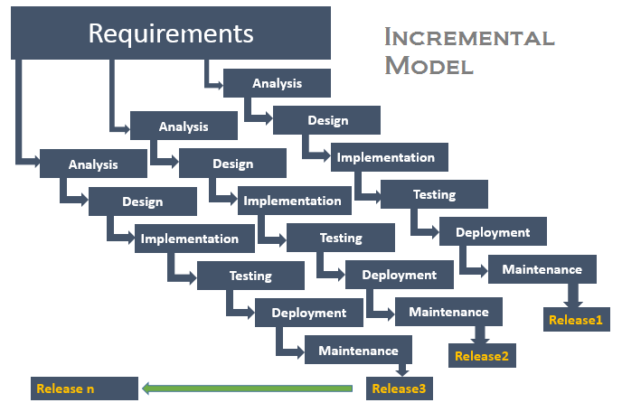Incremental funding is allowed, means only one or two increments might be funded when the program starts.

Chapter - 4

System Design

4.1 System Requirement Specification:-

Table 4.1 System Requirement Specification

|  |  |  |  |  |
| --- | --- | --- | --- | --- |
| Actor | Main Activity | Database Activity | Activity in Table | Document |
|  |  |  |  |  |
| Buyer | Sign-Up | Create | Cart |  |
|  |  | Update | Buyer |  |
|  |  |  |  |  |
|  | Product Add to Cart | Update | Cart |  |
|  |  |  |  |  |
|  | Place Order | Update | Cart |  |
|  |  | Update | Current_Order |  |
|  |  | Update | Order_Details |  |
|  |  |  |  |  |
|  | Order Cancel | Update | Order Status in Order |  |
|  |  |  |  |  |
|  | Order Delivered | Update | Finished_Order | Bill Generated |
|  |  |  |  |  |
|  | Order Replace | Update | Order_Details | New Bill Generated |
|  |  | Update | Finished_Order |  |
|  |  |  |  |  |
|  | Account Delete | Delete | Cart |  |
|  |  | Update | Buyer |  |
|  |  |  |  |  |
|  | Update Profile | Update | Buyer |  |
|  |  |  |  |  |
| Guest | Guest Place Order | Create | Temp Cart |  |
|  |  | Update | Temp Cart |  |
|  |  | Update | Current_Order |  |
|  |  | Update | Order_Details |  |

|  |  |  |  |  |
| --- | --- | --- | --- | --- |
| Admin | Add Products | Update | Product |  |
|  |  |  |  |  |
|  | Edit Products | Update | Product |  |
|  |  |  |  |  |
|  | Remove Products | Update | Product |  |
|  |  |  |  |  |
|  | Block/Unblock Buyer | Update | Buyer |  |
|  |  |  |  |  |
|  | Block/Unblock Seller | Update | Seller |  |

4.2 Organization chart

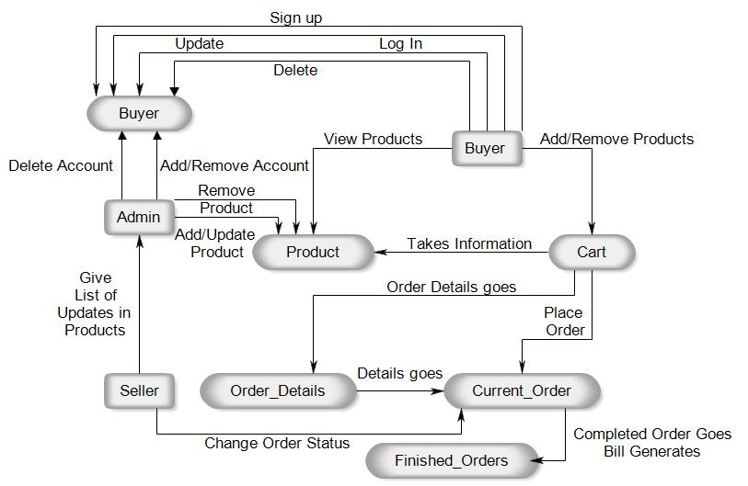

Figure 4.2 Organization Chart

4.3 E-R Diagram

* E-R Diagram is a graphical tool to represent the model, and logical structure of database (Entity and Relationship exist among entity set)
* Components of ER Diagram:-

1. Entity
2. Attributes
3. Relationship
4. Key attributes

* There are two types of Entity:-

1. Strong Entity
2. Weak Entity

* Symbols:

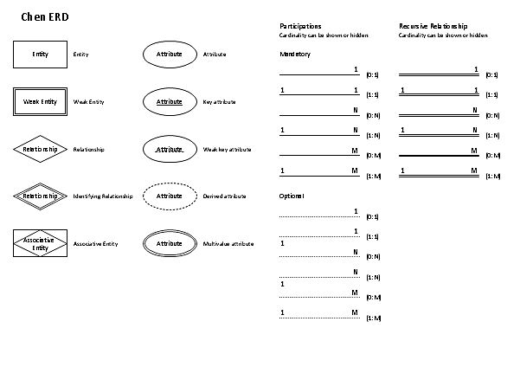

4.3 E-R Diagram of E-Mart

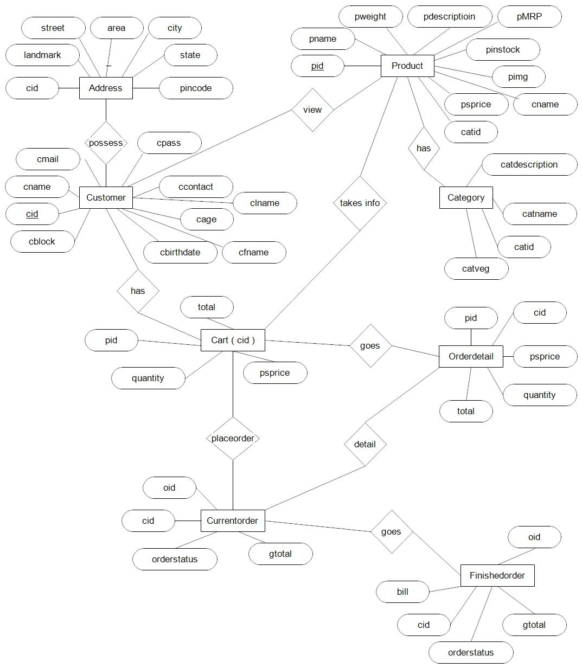

Figure 4.3 E-R Diagram

4.4 Data Flow Diagram

* 0 Level DFD

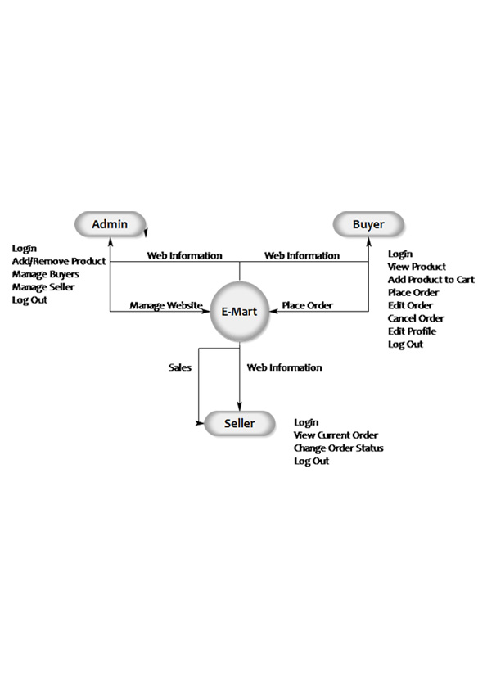

Figure 4.4.1 - 0 Level DFD

* 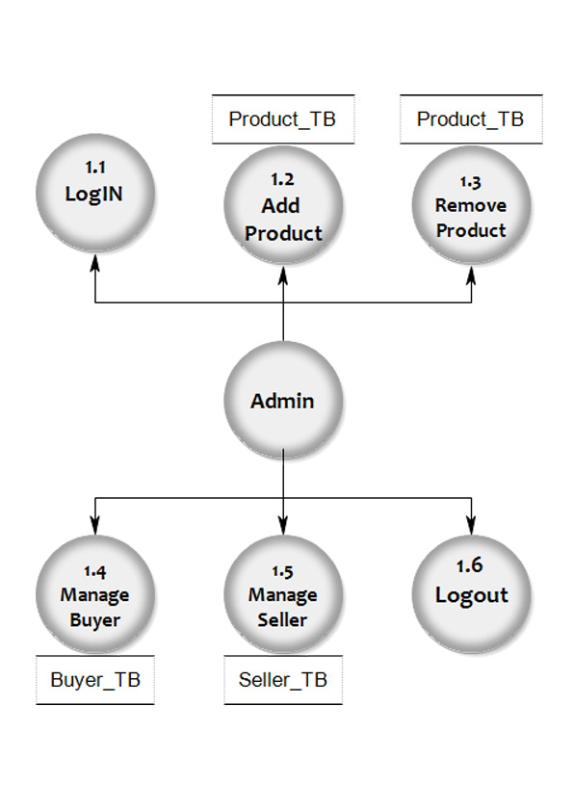1st Level DFD – Admin

Figure 4.4.2 – 1st Level DFD - Admin

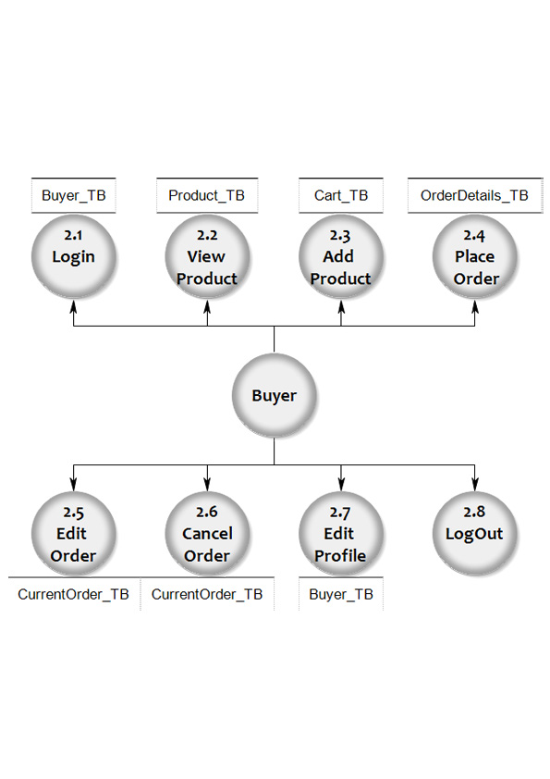

* 1st Level DFD – Buyer

Figure 4.4.3 – 1st Level DFD - Buyer

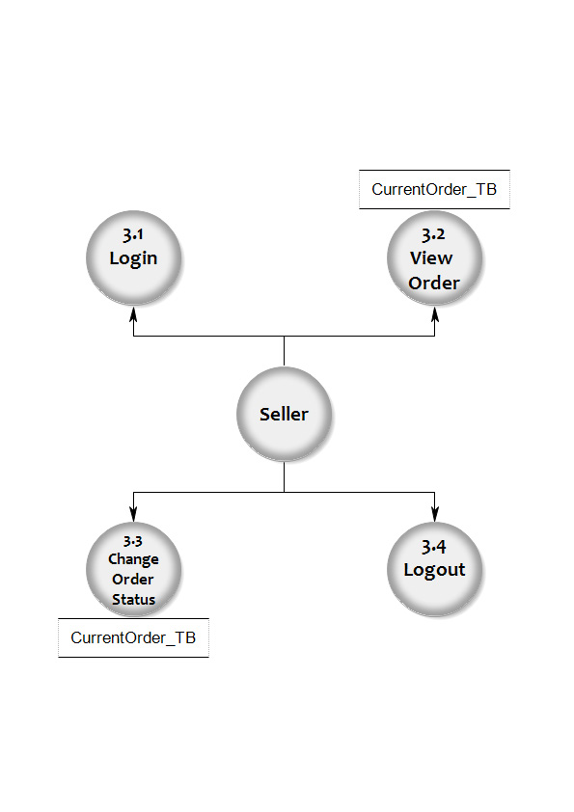

* 1st Level DFD – Seller

Figure 4.4.4 – 1st Level DFD - Seller

* 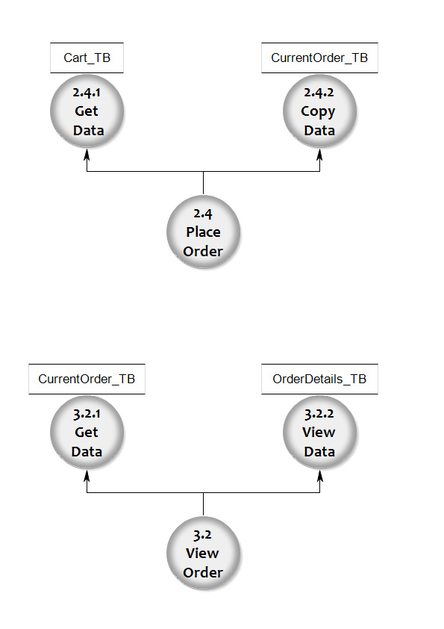2nd Level DFD

Figure 4.4.5 – 2nd Level DFD –Place Order (Buyer)

Figure 4.4.6 – 2nd Level DFD –View Order(Seller)

4.5 Data Dictionary

* Table 4.5.1 Buyer:-

|  |  |  |  |
| --- | --- | --- | --- |
| Column Name | Data Type | Size | Constraint |
| Cid | Int | Auto Inc. | Primary key |
| Fname | Varchar | 25 |  |
| Lname | Varchar | 25 |  |
| Cname | Varchar | 25 | Unique |
| Cmail | Varchar | 50 | Unique |
| Cpass | Varchar | 15 |  |
| Contact | Int | 10 |  |
| Contact2 | Int | 10 |  |
| Gender | Boolean |  |  |
| Cimg | Varchar | 255 |  |
| Birthdate | Date |  |  |
| Blocked | Boolean |  |  |

* Table 4.5.2 Address:-

|  |  |  |  |
| --- | --- | --- | --- |
| Column Name | Data Type | Size | Constraint |
| Cid | Int | Auto Inc. | Foreign key |
| Add1 | Varchar | 100 |  |
| Add2 | Varchar | 100 |  |
| Landmark | Varchar | 50 |  |
| Area | Varchar | 25 |  |
| City | Varchar | 25 |  |
| State | Varchar | 25 |  |
| Pin code | Int |  |  |

* Table 4.5.3 Cart:-

|  |  |  |  |
| --- | --- | --- | --- |
| Column Name | Data Type | Size | Constraint |
| Pid | Int | Auto Inc. | Foreign key |
| Quantity | Int | 10 |  |
| Sprice | Int | 10 |  |
| Total | Int | 10 |  |

* Table 4.5.4 Product:-

|  |  |  |  |
| --- | --- | --- | --- |
| Column Name | Data Type | Size | Constraint |
| Pid | Int | Auto Inc. | Primary key |
| Catid | Varchar | 15 |  |
| Pname | Varchar | 50 |  |
| Weight | Int | 10 |  |
| Mrp | Int | 10 |  |
| Sprice | Int | 10 |  |
| Instock | Int | 10 |  |
| Pdesc | Varchar | 500 |  |
| Pimg | Varchar | 1000 |  |
| Visible | Boolean |  |  |

* Table 4.5.5 Category:-

|  |  |  |  |
| --- | --- | --- | --- |
| Column Name | Data Type | Size | Constraint |
| Catid | Varchar | 15 | Primary key |
| Catname | Varchar | 25 |  |
| Catdesc | Varchar | 500 |  |
| veg | Boolean |  |  |

* Table 4.5.6 Current_Order:-

|  |  |  |  |
| --- | --- | --- | --- |
| Column Name | Data Type | Size | Constraint |
| Oid | Int | 10 |  |
| Cid | Int | 10 |  |
| Gtotal | Int | 11 |  |
| status | Int | 2 |  |

* Table 4.5.7 Order_Details:-

|  |  |  |  |
| --- | --- | --- | --- |
| Column Name | Data Type | Size | Constraint |
| Oid | Int | 11 | Foreign key |
| Pid | Int | 10 | Foreign key |
| Quantity | Int | 10 |  |
| Sprice | Int | 10 |  |
| Total | Int | 10 |  |

* Table 4.5.8 Finished_Orders:-

|  |  |  |  |
| --- | --- | --- | --- |
| Column Name | Data Type | Size | Constraint |
| Oid | Int | 10 |  |
| Cid | Int | 10 |  |
| Gtotal | Int | 11 |  |
| status | Int | 2 |  |
| Bill | Varbinary | 500 |  |

Chapter-5

Form Layout

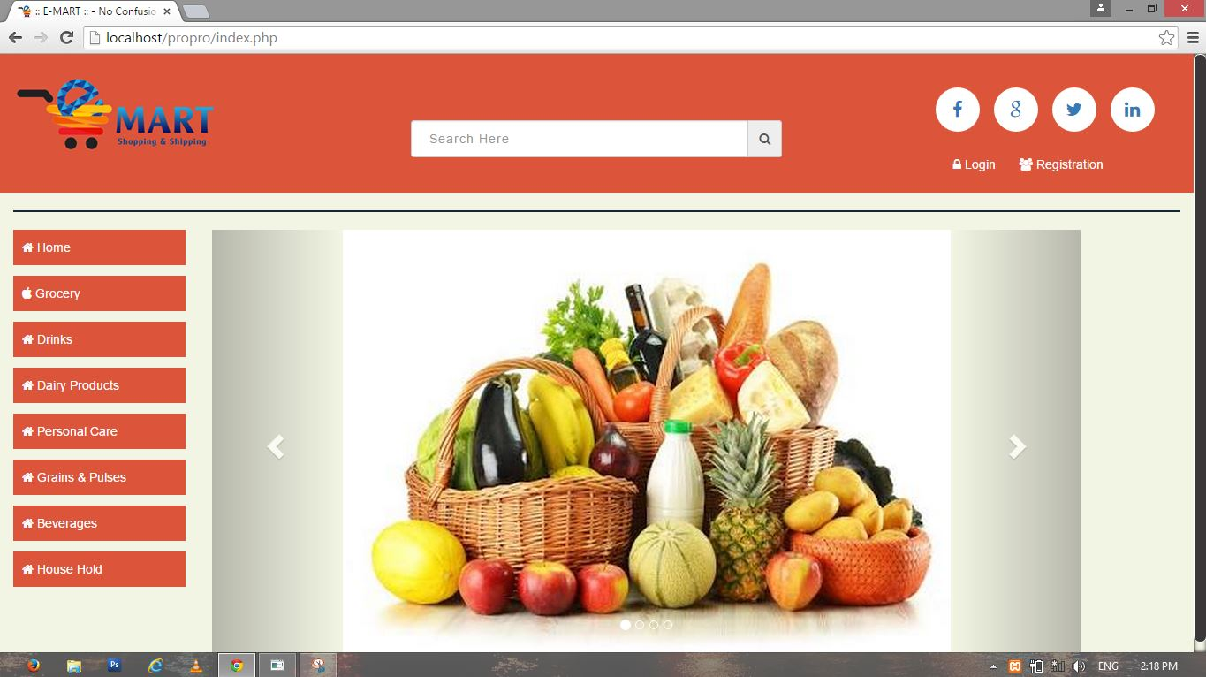

Figure 5.1 - Home Page

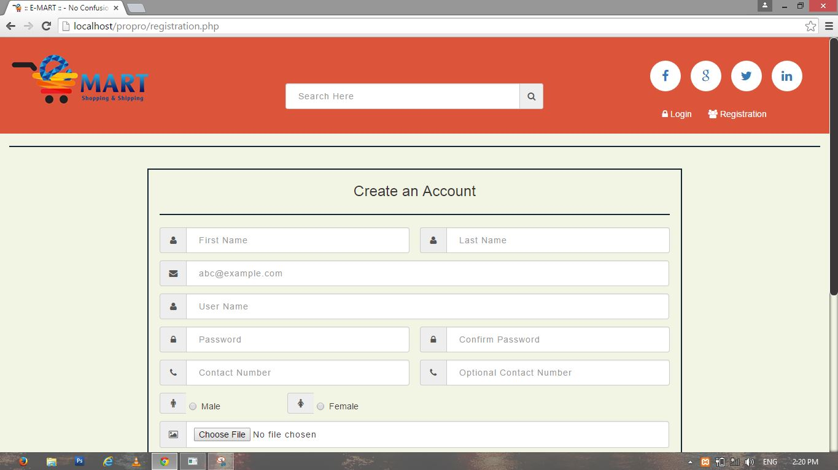

Figure 5.2 – Registration

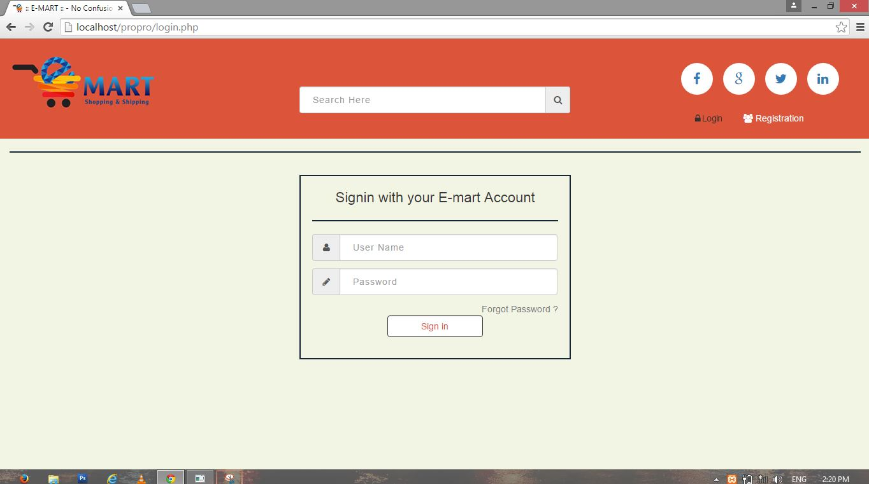

Figure 5.3 - Login

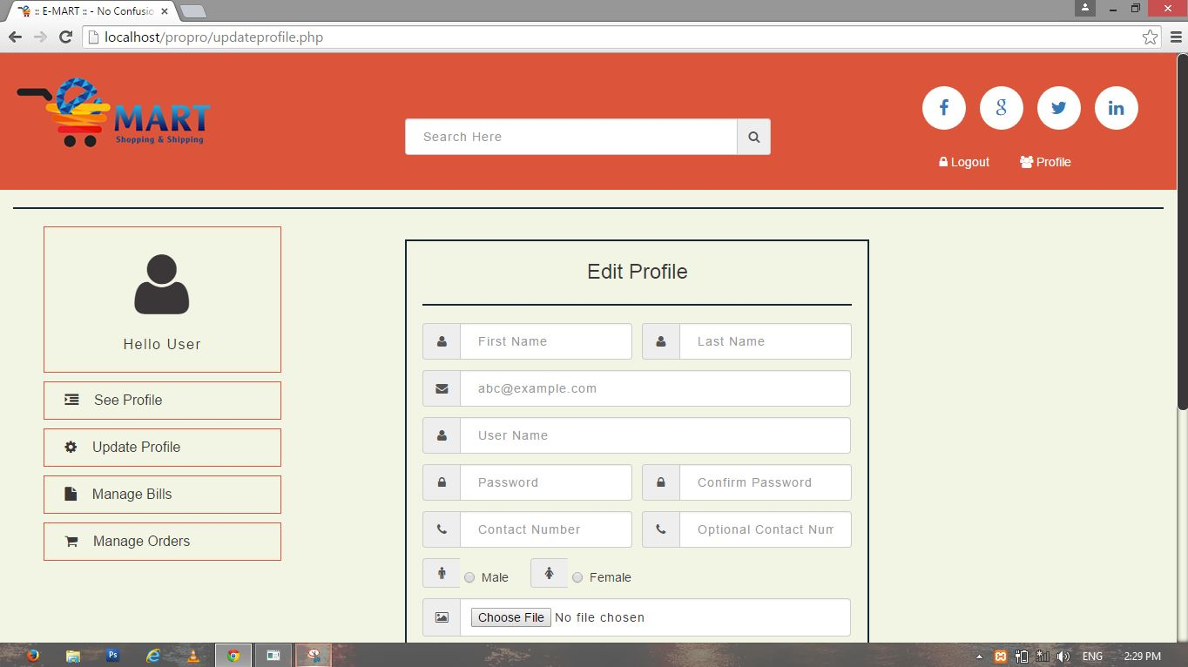

Figure 5.4 – User Home

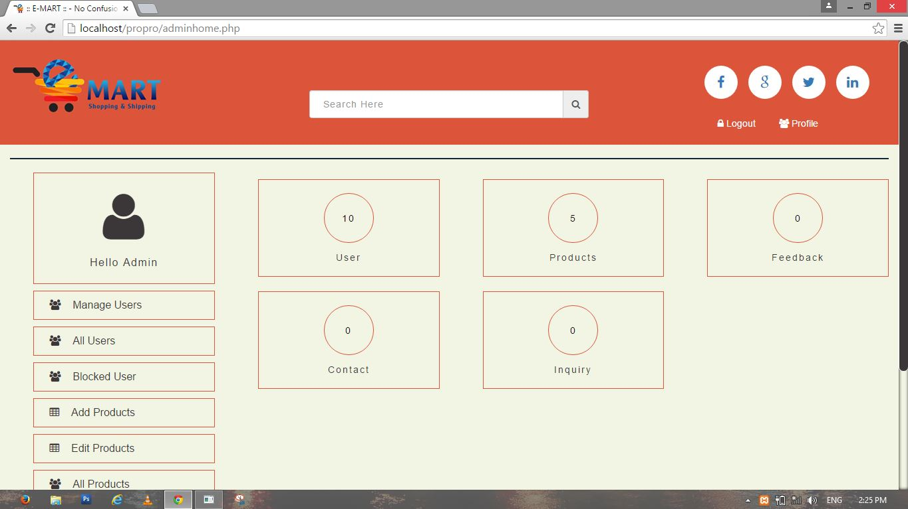

Figure 5.5 – Admin Home

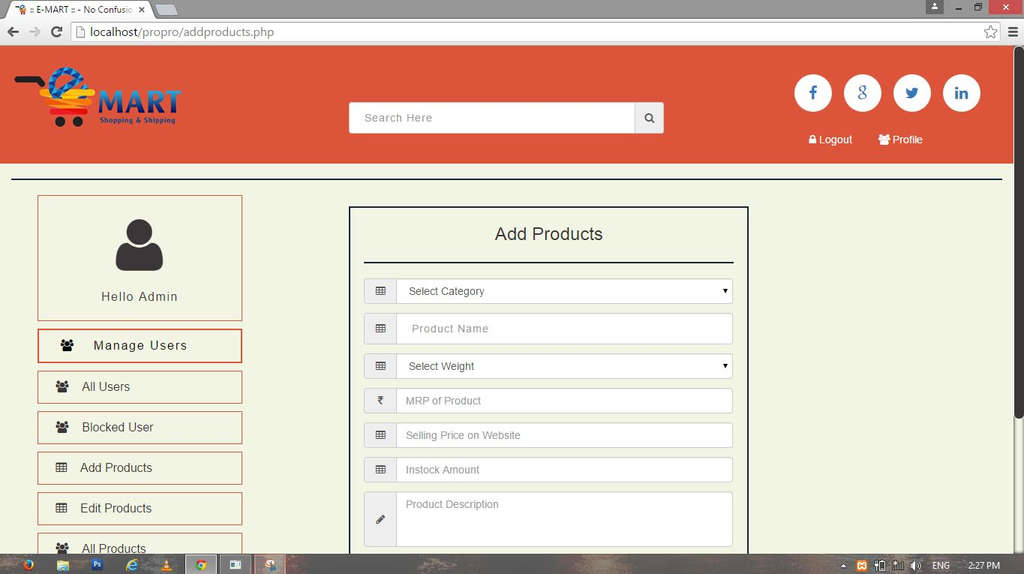

Figure 5.6 – Add Products

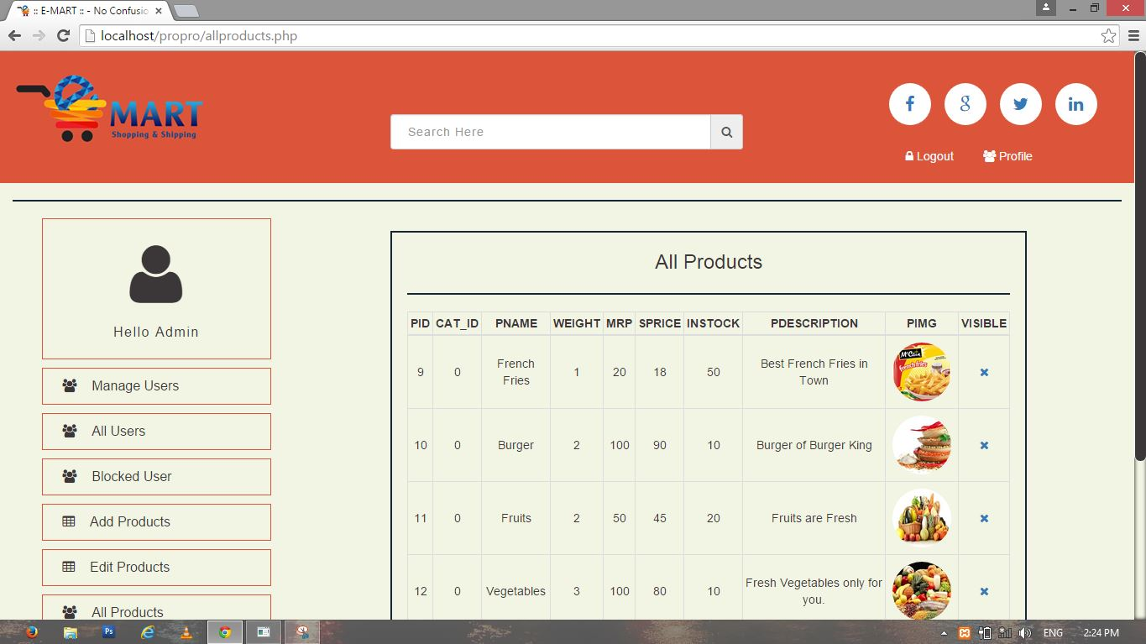

Figure 5.7 – All Products

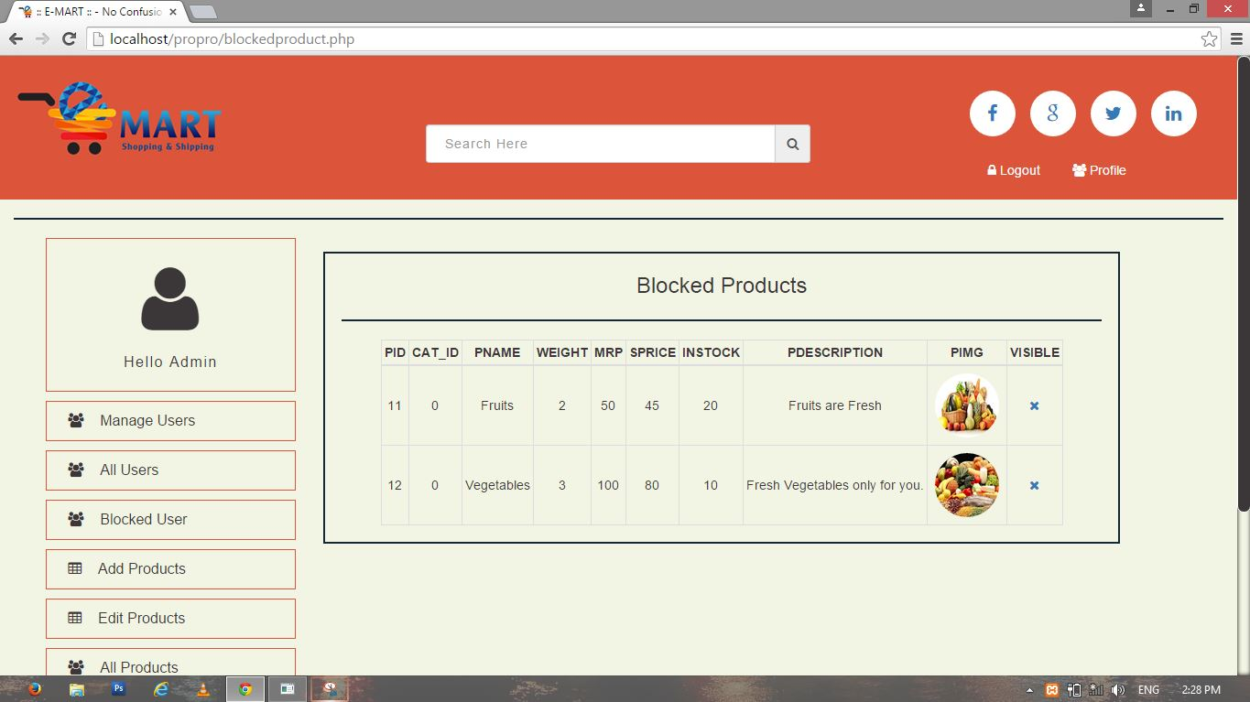

Figure 5.8 – Blocked Products

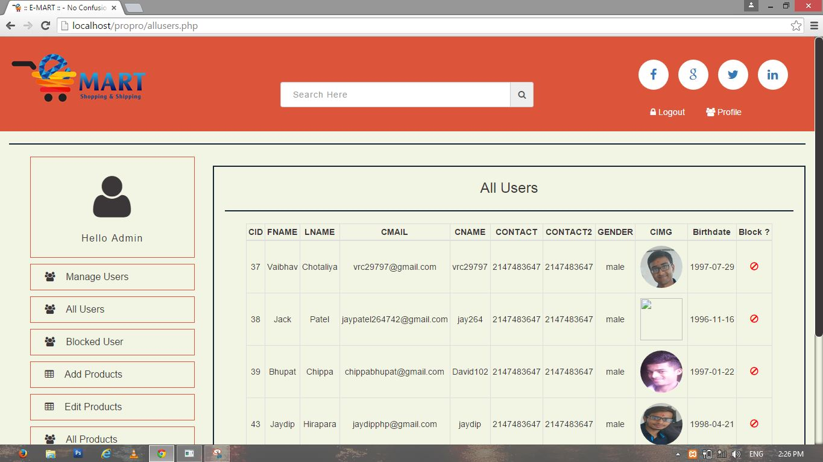

Figure 5.9 – All Users

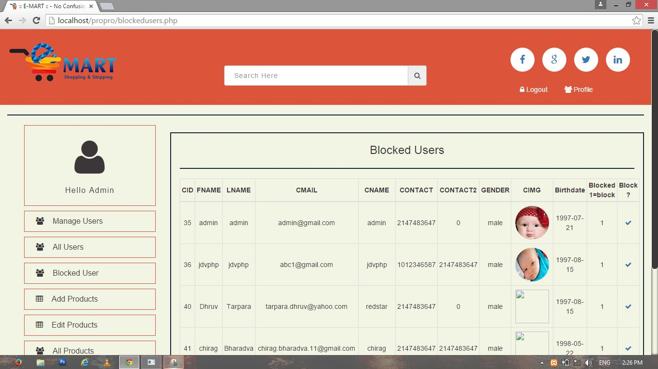

Figure 5.10 – Blocked Users

Chapter-6

Tools Specifications

6.1 Software Specifications:-

6.1.1 Front End:-

* PHP (5.6.8)
* HTML5
* CSS3
* JavaScript

PHP:-

* PHP is a server scripting language and a powerful tool for making dynamic and interactive web pages.
* PHP is widely used, free and efficient alternative to competitive such as Microsoft’s ASP.
* PHP is a free software (Open Source) related under PHP license.
* Founder of PHP is Rasmus Lardorf. PHP was written in the 7 programming language in 1994.
* Original meaning of PHP is Personal Home Page.
* Core PHP was rebuilt by Zeev Suraski and Andi Gutmans in 1997 and names “Hypertext Pre-processor”.

CSS:-

* A cascading Style sheet contains style rules that are applied to element in a webpage.
* CSS defines how HTML elements are to be displayed.
* CSS saves a lot of work and external style sheets are stored in CSS files.

JavaScript:-

* JavaScript is a programming language of HTML and the Web.
* JavaScript is a dynamic Programming language.
* It is most commonly used as part of web browsers, whose implementation allow client-slide script to interact with user, control browser, communicate asynchronously, and alter the document, content that is displayed.
* JavaScript is multi-paradigm language, support OOP, imperative and functional programming Style.

6.1.1 Back End:-

* MySQL 5.5.32

MySQL:-

* MySQL is open source relational database management system that relies on SOL for processing data in the database.
* MySQL falls under the GNU General Public License.
* MySQL is most commonly used for web application because of its speed and reliability.
* MySQL provides a very high performance and it is multi-thread and multi-user relational database management system.
* MySQL is very lightweight application and support indexing and binary object.

6.2 Other Tools:-

* XAMPP Software Package (3.2.1)
* Adobe Dreamweaver CC 2015

XAMPP:-

* XAMPP is a light-weight easy to install bundle that will allows us to do local development on website in case we don’t have server hosted.
* It is an open Source licensed product.
* XAMPP consist of three main things that we need to know is:
* Apache web Server
* PHP
* MySQL
* Hence, these three things are included in the XAMPP.

Chapter -7

Conclusion

7.1 Advantages:-

* E-mart offers several advantages to consumer and companies including improvements of productivity, customer satisfaction and general overall productivity.
* E-mart provides a wider scope of consumer that can be attained by the entrepreneur.
* This will create an easier way for customer to buy items that the business is offering and also can view reviews of the product and customer service.
* Customer would now be able to view and get update on their favorite brands or products and special discount that apply and would be able to make purchase any time.
* Customer will have direct access to the product information, company, promotion and much more.

7.2 Limitation:-

* Geographical limitations.
* Product information must be update at arbitrary interval.
* Payment methods are limited.

7.3 Future Scope:-

* Widen the range of product sold.
* Provide more payment methods.
* Widen the geographical area.

Chapter - 8

Bibliography

8.1 Books:-

* PHP with MY SQL
* PHP 5
* Dynamic Web Programming using PHP

8.2 Websites:-

* [www.w3schools.com](http://www.w3schools.com)
* [www.tutorialspoint.com](http://www.tutorialspoint.com)
* [www.getbootstrap.com](http://www.getbootstrap.com)

Appendix

Tables:-

|  |  |  |  |
| --- | --- | --- | --- |
| Sr.No | Table. No | Name | Page Number |
| 1 | 4.1 | SRS | 19 |
| 2 | 4.5.1 | Buyer | 28 |
| 3 | 4.5.2 | Address | 28 |
| 4 | 4.5.3 | Cart | 28 |
| 5 | 4.5.4 | Product | 29 |
| 6 | 4.5.5 | Category | 29 |
| 7 | 4.5.6 | Current_Order | 29 |
| 8 | 4.5.7 | Order_Details | 30 |
| 9 | 4.5.8 | Finished_Orders | 30 |

Figures/Images:-

|  |  |  |  |
| --- | --- | --- | --- |
| Sr.No | Fig. No. | Name | Page Number |
| 1 | 4.2 | Organization Chart | 20 |
| 2 | 4.3 | ER Diagram | 22 |
| 3 | 4.4.1 | 0 Level DFD | 23 |
| 4 | 4.4.2 | 1st Level DFD Admin | 24 |
| 5 | 4.4.3 | 1st Level DFD Buyer | 25 |
| 6 | 4.4.4 | 1st Level DFD Seller | 26 |
| 7 | 4.4.5 | 2nd Level DFD Place Order (Buyer) | 27 |
| 8 | 4.4.6 | 2nd Level DFD View Order (Seller) | 27 |
| 9 | 5.1 | Home Page | 28 |
| 10 | 5.2 | Register | 28 |
| 11 | 5.3 | Login | 29 |
| 12 | 5.4 | User Home | 29 |
| 13 | 5.5 | Admin Home | 30 |
| 14 | 5.6 | Add Product | 30 |
| 15 | 5.7 | All Products | 31 |
| 16 | 5.8 | Blocked Product | 31 |
| 17 | 5.9 | All Buyers | 32 |
| 18 | 5.10 | Blocked Buyers | 32 |